Government of Karnataka
People’s Biodiversity Register (PBR)

Gram Panchayat :

Taluk :

District :

Add Photo

Published By
Karnataka Biodiversity Board
(Department of Forest, Ecology and Environment) “Vanavikas”, 18th cross, Malleshwaram, Bangalore 560003 Phone 08023448783, Fax 080-23440535
Email: kbb-ka@nic.in Website: www.kbb.kar.nic.in

Government of Karnataka
People’s Biodiversity Register (PBR)

Gram Panchayat :

Taluk :

District :

Add Photo

Published By
Karnataka Biodiversity Board
(Department of Forest, Ecology and Environment) “Vanavikas”, 18th cross, Malleshwaram, Bangalore 560003 Phone 08023448783, Fax 080-23440535
Email: kbb-ka@nic.in Website: www.kbb.kar.nic.in
Deputy Conservator of Forest
Social Forestry division, District

Foreword
Biological Diversity Act, 2002 aims to promote conservation, sustainable use and equitable sharing of benefits arising out of the use of India’s biological resources. The Act provides for constitution of Biodiversity Management Committees (BMCs) at all local bodies for the purpose of promoting conservation, sustainable use and documentation of Biological Diversity and chronicling of knowledge relating to Biological Diversity.
One of the main functions of BMCs’ is the preparation of People’s Biodiversity Registers (PBRs). The PBR is a comprehensive document on biological resources and associated traditional knowledge. The preparation of PBRs is a huge task which involves students, teachers and local knowledgeable persons. The
preparation of PBR in Gram Panchayath, -
Taluk, District of Karnataka was
undertaken by Karnataka Biodiversity Board. The Board has provided the leadership and guidance to concerned Biodiversity Management Committee to achieve this objective.
The documentation of Biodiversity empowers the local bodies to establish and exercise its sovereign rights over biological resources in their jurisdictions. I thank all those who have joined hands with the Karnataka Biodiversity Board and contributed for PBR preparation, a task of national importance. Further, I thank the office bearers of Biodiversity Management Committees for their effort.
The documentation of biodiversity and prescription listed will go a long way in proper management, conservation and sustainable use of biodiversity so that the future generation is also able to benefit from it.
( -Sd- )

Deputy Conservator of Forest (Social Forestry) and

Nodal Officer

Acknowledgement

List of Certificates
1. Biodiversity Management Committee format.

2. Biodiversity Management Committee resolution certificate from the Gram Panchayat.

3. Attendance certificate from the Gram Panchayat PDO. (Visiting dates should be mentioned)

4. Technical Expert Committee(TEC) meeting proceeding copy. (Collect the proceeding copy from DCF(SF) office)

5. Approval certificate signed by DCF(SF) and CEO/his representative.
(Collect the certificate from DCF(SF) office. (After doing all the corrections suggested in the TEC meeting)

6. Approval certificate from the PDO and BMC Chair person. (Collect the certificate after doing the corrections suggested in the TEC meeting.)

7. Coordinators Certificate(signed by the coordinator)
Index

Sl.  No. | Subject | Page No.
1 | Foreword | I
2 | Acknowledgement | II
3 | BMC Member List | III
4 | Certificate | IV
5 | Index
Part - I
6 | 1.0 Introduction
7 | 1.1 Biodiversity Act and rules
8 | 2.0 Biodiversity Register
9 | 2.1 Present status and reporting system of Biodiversity
10 | 2.2 Biodiversity Management Committee
11 | 3.0 People’s Biodiversity Register and Role of NBA
12 | 4.0 People’s Biodiversity Register
13 | 4.1 Purpose of preparation of PBR
14 | 4.2 Process adopted in PBR preparation
15 | 5.0 People’s Biodiversity Register: General details
16 | 5.1 Habitat and Topography description
17 | 5.2 Climate (Rainfall, Temprature)
18 | 5.3 Land Use

19 | 5.4 Details of Forest and Waste land
20 | Annexure-1
21 | Annexure-2
22 | Annexure-3
23 | Annexure-4
24 | Annexure-5
25 | Maps
26 | Photos
Part- II
27 | Format 1 Crop Plant
28 | Format 2 Fruit Plants
29 | Format 3 Fodder crops
30 | Format 4 Weeds
31 | Format 5 Pests of Crops
32 | Format 6 Peoplescape
33 | Format 7 Landscape
34 | Format 8 Waterscape
35 | Format 9 Soil type
36 | Format 10 Medicinal Plants

37 | Format 11 Ornamental plants
38 | Format 12 Timber, Bamboo, Cane etc
39 | Format 13 Domesticated animals
40 | Format 14 Markets / fairs for domesticated animals
41 | Format 15 Market/Fairs for Medicinal Plants and other plant products
42 | Format 16, Flora (Trees, Shrubs, Herbs, Tubers, Grasses, Climbers)
43 | Format 17, Fauna (Mammal, Birds, Reptile, Amphibians, Insects and others)
44 | Format 18 Wild Plants of Medicinal Importance
45 | Format 19 Wild relatives of Crops
46 | Format 20 Ornamental Plants
47 | Format 21 Fumigate/Chewing Plants
48 | Format 22 Timber Plants
49 | Format 23 Aquatic faunal diversity (Fishes, Insects, Prawn, Crabs, Otter, Snakes, Tortoise, etc)
50 | Format 24 Aquatic floral Diversity
51 | Format 25 Culture Fisheries
52 | Part - III
53 | Abbreviations
54 | References

Part I

1.0 The Biological Diversity Act, 2002 & Rules, 2004

The Biological Diversity Act, 2002 (No. 18 of 2003) was notified by Government of India on 5th February, 2003. The Act extends to the whole of India and reaffirms the sovereign rights of the state over its biological resources. Subsequently the government of India published Biological diversity Rules, 2004 (15 th April, 2004). The Rules under section 22 states that ‘every local body shall constitute a Biodiversity Management Committee (BMC’s) within its area of jurisdiction’.

2.0 People’s Biodiversity Registers and the role of the Biodiversity Management Committee

The mandate of the Biodiversity Management Committee has been clearly highlighted in the Biodiversity Rules 2002 as follows:
- The main function of the BMC is to prepare People’s Biodiversity Register in consultation with the local people. The Register shall contain comprehensive information on availability and knowledge of local biological resources, their medicinal or any other use or any other

- The other functions of the BMC are to advice on any matter referred to it by the State Biodiversity Board or Authority for granting approval, to maintain data about the local vaids and practitioners using the biological resources.

- The Authority shall take steps to specify the form of the People’s Biodiversity Registers, and the particulars it shall contain and the format for electronic database.
- The Authority and the State Biodiversity Boards shall provide guidance and technical support to the Biodiversity Management Committees for preparing People’s Biodiversity Registers.
- The People’s Biodiversity Registers shall be maintained and validated by the Biodiversity Management Committees.

3.0 People’s Biodiversity Registers and the role of National Biodiversity Authority (NBA)

The National Biodiversity Authority shall provide guidance and technical support to the Biodiversity Management Committee (BMC) for preparing People’s Biodiversity Register

People’s Biodiversity Registers and the role of State Biodiversity Board (SBB)

The State Biodiversity Board (SBB) would provide necessary training to the Technical Support Group (TSG) of the district and enable smooth functioning and aid in networking for creation and maintenance of People’s Biodiversity Registers (PBRs).

People’s Biodiversity Registers and Role of the Technical Support Group (TSG)

The Technical Support Group (TSG) will consist of experts drawn from various disciplines and line departments, universities, research institutes, colleges and schools and non-governmental organizations. The Technical Support Group will provide technical inputs and advice to the BMCs on identification of plants and animals, monitor and evaluate the PBR exercise, examine confidential information and advice on legal protection, maintain a database of local and external experts on biodiversity

People’s Biodiversity Registers (PBR)

The evolution of human societies over several millennia is closely related to plants and animals. The domestication of crop plants and farm animals about 12000 years ago revolutionized the human civilization by creating more stabilized societies. The early historic and medieval period gradually reduced human interaction with the wild plants and animals. The development of modern science and technologies during the industrial and post-industrial period did not do away with our link to nature. Different groups of people continue to depend on natural resources at varying scales. Some draw resources from across continents while others within a country or a region. There are also people continue to depend on locally available biodiversity and bio-resources for their livelihoods. Such population who are directly dependent on local biological resources have, through their keen sense of observation, practices, and experimentation developed and established a body of knowledge that is passed on from generation to generation. Some are widespread traditional knowledge like cultivation practices; others are highly specialized such as bone setting or jaundice, which are generally passed only to close members of the family.

India is land of biological and cultural diversity. It is one of the ten-mega biodiverse countries of the world. It also the home of a large number of tribal groups, pursing different kinds of nature based livelihoods. In addition, a large number of farming and fishing communities and nomadic groups posses traditional knowledge of varying degrees. The development of modern science and technologies notably biotechnology and information technologies have increased the value of biodiversity and associated knowledge including traditional knowledge (TK) .The growing importance of biodiversity, bio-resources and associated knowledge is fairly well understood. The first step towards conservation r sustainable utilization of biodiversity is its documentation. Biodiversity and associated knowledge is found in different ecosystems, under different legal management regimes and hence the results and manner of documentation will also differ.

The present manual guidelines have drafted taking into consideration different ecosystems and include the rural urban and protected areas. The guidelines may be customized and further information may be added to enrich the effort. It is important to keep in mind some of the issues related to PBRs:

- It is to be undertaken in a participatory mode involving varying sections of village society.

- While documenting, the knowledge and views of both genders are to be recorded.

- Information provided by people need to be collated, analysed and crosschecked by the members of the Technical Support Group (TSG) before documentation.
- The PBR is important base document in the legal arena as evidence of prior knowledge and hence careful documentation is necessary.
- The document should be endorsed by the BMC and later publicized in the Gram Sabha / Gram Panchayat / Panchayat Samiti. The document can be a very useful tool in the management and sustainable use of diversity. The document can also be a very useful teaching tool for teaching environmental studies at schools, colleges and university level

- The document should be periodically updated with additional and new information as and when generate.

The PBR Process

The preparation of People’s Biodiversity Registers (PBRs) involves the active support and cooperation of a large number of people who need to share their common as well as specialized knowledge. One of the first steps for preparing a PBR is to organize a group meeting to explain the objectives and purpose of the exercise. Different social groups in the village need to be identified for purpose of data collection from those groups. In an urban situation, spots where biodiversity are important need to be identified for the purpose of the study and documentation. The documentation process includes information gathered from individuals through detailed questionnaire, focused group discussion with persons having knowledge and published secondary information.

Documentation of Traditional Knowledge (TK) related to biodiversity

Documentation of knowledge of individuals with regard to biodiversity and its uses is an important part of PBR. Every effort should be made to identify the persons with proven knowledge of local biodiversity; special attention should be given to the elderly persons who can also provide informations on the biodiversity which was available in the past but no longer seen at present. In some cases focus group discussion may be held for the purpose of documentation.

PBR Methodology

The PBR is a participatory process requiring intensive and extensive consultation with the people. The objectives and purpose is to be explained in a group meeting in the presence of all sections of people in the Panchayat, members of the BMC, students, knowledgeable individuals and all those interested in the effort. Documentation includes photographs (including digital images), drawings, audio and video recordings and other records like printed material.

Process in PBR Preparation

Step 1 Formation of Biodiversity Management Committee (BMC)

Step 2 Sensitization of the public about the study, survey and possible management

Step 3Training of members in identification and collection of data on biological resources and traditional knowledge
Step 4 Collection of data. Data collections includes review of literature on the natural resources of the districts, Participatory Rural Appraisal (PRAs) at village level, housel hold interviews, individual interviews with village leaders and knowledgeable individuals, household heads, key actors of the panchayat raj institutions and NGOs and direct field observations

Step 5 Analysis and validation of data in consultation with technical support group and BMC

Step 6 Preparation of People’s Biodiversity Register (PBR)

Step 7 Computerization of information and resources

Introduction and history of the Gram Panchayath
Peoples’ Biodiversity Register (PBR): General Details

Name of the Panchayat Samity :

Taluk :

District :

State :

Geographical Area of the Panchayat Samity:

Population under the Panchayat Samity: Total Male Female
Habitat and Topography :

Climate (Rainfall, Temperature and other weather patterns)

Land Use (Nine fold classification available with village records) Date, Month and Year of PBR preparation
Management Regime: Reserve Forests (RF) / Joint Forest Management (JFM) / Protected Areas (PA) / Community Owned and Managed Forests (COM)

Annexure 1
:
:
:
:
:
5) Name
Age Gender Address
Area of specialization
:
:
:
:
:
4) Name
Age Gender Address
Area of specialization
:
:
:
:
:
3) Name
Age Gender Address
Area of specialization
:
:
:
:
:
2) Name
Age Gender Address
Area of specialization
:
:
:
:
:
1) Name
Age Gender Address
Area of specialization
Details of Biodiversity Management Committee (BMC) of the panchayat (One elected
Chairperson and six persons nominated by the local body; not less than one third to be women and not less than 18% belonging to SC/ST)

Annexure 2
:
:
Location from which the person accesses biological material
Perception of the practitioner on the resource status
:
:
:
:
:
Name
Age Gender Address
Area of Specialization
:
:
Location from which the person accesses biological material
Perception of the practitioner on the resource status
:
:
:
:
:
Name
Age Gender Address
Area of Specialization
:
:
Location from which the person accesses biological material
Perception of the practitioner on the resource status
:
:
:
:
:
Name
Age Gender Address
Area of Specialization
List of Vaids, hakims and traditional health care (human and livestock) practitioners residing
and or using biological resources occurring within the jurisdiction of the village

Annexure 3
:
:
:
:
:
Name
Age Gender Address
Area of specialization
:
:
:
:
:
Name
Age Gender Address
Area of specialization
:
:
:
:
:
Name
Age Gender Address
Area of specialization
:
:
:
:
:
Name
Age Gender Address
Area of specialization
List of individuals perceived by the villagers to possess Traditional Knowledge (TK) related to
biodiversity in agriculture, fisheries, and forestry

Annexure 4
Details of schools, colleges, departments, universities, government institutions, nongovernmental organization and individuals involved in the preparation of the PBR

- Contact Person :
Name and Address :

- Contact Person :
Name and Address :

- Contact Person :
Name and Address :

- Contact Person :
Name and Address :

You may add names of more institutions / NGO / Individuals, etc. if necessary.

Annexure 5
Details of access to biological resources and traditional knowledge granted, details of the collection fee imposed and details of the benefits derived and the mode of their sharing

No | Name and address of the Person /institution/ company/ others | Local and Scientific Name of the biological  material Accessed and quantity | Date and resolution of the BMC and  endorsement by the panchayat | Details of collection fee imposed | Anticipated mode of sharing benefits or quantum of benefits shared

District Map

Taluk Map

Gram Panchayath Map

.

Field and Special Biodiversity Photographs

(BMC meeting photo, Field visit photo, special biodiversity photo etc ) Add 20- 25 photos(4 photos/page)

PART - 2
Part II
PBR – Formats
AGRO-BIODIVERSITY
Format 1: Crop Plants
1 | 2 | 3 | 4 | 5 | 6 | 7 | 8 |  | 9 | 10 | 11 | 12 | 13 | 14 | 15
Sl.No | Crop | Scientific Name | Local Name | Variety | Landscape  /Habitat | Approx.  area shown (Hectare) | Status |  | Special features | Cropping season | Use | Associated  TK | Other details | Source of  Seeds/ Plants | Community/ Knowledge Holder
 |  |  |  |  |  |  | Past | Present

- The format could be used for documenting information about Millets, Cereals, Oil seeds, Commercial Crops, Tuber Crops, Vegetables, Legumes, Aromatic Crops etc.
- Other details: vary with the nature of Crops.
- For measuring local status, there need to identify a particular year- significant changes in ecology occurred – and Compare the status as past and present (past = before the particular incident).
- We have to list out all possible features of a Crop/ Plant and give short forms of the same.
- If relevant, cultivation practices, propagation techniques, usage etc. can be including in associated TK.

Format 2: Fruit Plants
1 | 2 | 3 | 4 | 5 | 6 | 7 |  | 8 | 9 | 10 | 11 | 12 | 13
Sl.No | Plant type (herb, shrub, tree) | Scientific Name | Local Name | Variety | Landscape/Habitat | Status |  | Source of Seeds/Plants | Season of Fruiting | Associated TK | Use | Other details market/own use | Community/ Knowledge Holder
 |  |  |  |  |  | Past | Present

Format 3: Fodder Crop
1 | 2 | 3 | 4 | 5 | 6 |  | 7 | 8 | 9 | 10 | 11
Sl.No | Plant | Scientific Name | Local Name | Landscape/ Habitat | Status |  | Source of Seeds/ Plants | Associated TK | Part Used | Other details market/own use | Community/ Knowledge Holder
 |  |  |  |  | Past | Present

Other details include fodder for which animal, special features, medicinal uses if any, seasons of availability, propagation methods, collecting from wild or cultivated etc.

Format 4: Weeds
1 | 2 | 3 | 4 | 5 | 6 | 7 | 8 |  | 9 | 10 | 11 | 12 | 13
Sl.No | Plant | Scientific Name | Local Name | Affected crop | Impact | Landscape  Habitat | Status |  | Use if any | Management Options | Associated TK | Other details | Community  /Knowledge Holder
 |  |  |  |  |  |  | Past | Present

Other details may include how long the weeds have been attacking the Crops in this Locality, when it came under notice, intensity of natural multiplication etc.

Format 5: Pests of Crops
1 | 2 | 3 | 4 | 5 | 6 | 7 | 8 | 9 | 10 | 11
Sl.No | Host | Insect/ Animal | Scientific Name | Local Name | Habitat | Time/ season of attack | Management mechanism | Associated TK | Other details | Community/ Knowledge Holder

Host: the crop is being attacked
Other details may include possible reasons for insects/animal attack.

Format 6: People Scape
1 | 2 | 3 | 4 | 5 | 6 | 7 | 8 | 9 | 10 | 11 | 12
Sl.No | Community and Population | Families and Major occupation | Sub-occupation | Depending Landscape | Major resources accessed and seasons of access | Landscape management practices | Resource management practices | Caste/ tribe | Social  condition | Nature of inhabitants | No. Households

Major occupation may be farming. Sub-occupations could be fishing, Collection of NTFP animal husbandry, artisans and services.
Examples of depending landscapes are agriculture landscape, river, forest etc.
Major resources accessed could be agriculture resources of different nature, fish, birds, water, mud, and etc
How the community manages the landscapes they use for satisfying different needs, their strategies and perception.
How the community manages the resources they access for satisfying different needs, their strategies and perception, conflicts etc.

Format 7: Landscape
1 | 2 |  |  | 3 | 4 | 5 | 6 | 7 | 8 | 9 | 10 | 11 | 12 | 13
Sl.No | Major Landscapes |  |  | Sub-land  scapes | Features and approx. area | Ownership | General flora | General fauna | Users groups | Management Practices | General uses | Associated TK | Other details | Community accessed
 | Agriculture land | Pond | Fallow land

Provide a brief description of landscapes such as forest, plantations, cultivated land, estuary, pond, lake or other elements.

Format 8: Waterscape
1 | 2 | 3 | 4 | 5 | 6 | 7 | 8 | 9 | 10 | 11 | 12 | 13 | 14
Sl.No | Waterscape element type | Sub-type | Features and Approx. area | Ownership | General flora | General fauna | Major uses | User groups | Management practices | General uses | Associated TK | Other details | Community accessed

Element type examples: Ponds, Streams, Rivers, Lake, Canal, Tube-well, Dug-well etc.

Format 9: Soil Type
1 | 2 | 3 | 4 | 5 | 6 | 7 | 8 | 9 | 10
Sl.No | Soil Type | Color and Texture | Features | Soil Management | Plants/crops suitable | General Flora | General Fauna | Associated TK | Other information

DOMESTICATED BIODIVERSITY
Format 10: Medicinal Plants
1 | 2 | 3 | 4 | 5 | 6 | 7 | 8 |  | 9 | 10 | 11 | 12 | 13
Sl.No | Plant Type | Local Name | Scientific Name | Variety | Landscape/ Habitat | Source of plant/seeds | Status |  | Uses (Usage) | Parts used | Associated TK | Other details market/ own use | Community  /Knowledge  Holder
 |  |  |  |  |  |  | Past | Present

Note: uses: Food / veterinary Medicine / Human Medicine (Sub- divisions like for children, women etc)/Agriculture Purpose (Bio-pesticide)
Other details: propagation methods/ Harvesting period/ Cultivated or collected from wild or both, / perennial/annual/seasonal

Format 11: Ornamental Plants
1 | 2 | 3 | 4 | 5 | 6 | 7 | 8 | 9 | 10 | 11
Sl.No | Plant Type | Local Name | Scientific Name | Variety | Source of plant/seeds | Commercial/ non-commercial | Uses | Associated TK | Other details | Community/ Knowledge holder

Format 12: Timber, Bamboo, Cane etc
1 | 2 | 3 | 4 | 5 |  | 6 | 7 | 8 | 9 | 10
Sl.No | Local Name | Scientific Name | Habitat | Status |  | Wild/ home-garden | Other uses | Associated TK | Other details | Community/ Knowledge Holder
 |  |  |  | Past | Present

Note: other NTFP (Non timber forest product) uses such as fire wood, green manure, fodder, fruits, etc

Format 13: Domesticated Animals
1 | 2 | 3 | 4 | 5 | 6 | 7 | 8 |  | 9 | 10 | 11 | 12 | 13
Sl.No | Animal Type | Local Name | Scientific Name | Breed | Features | Method of keeping | Status |  | uses | Associated TK | Commercial rearing | Other details including products and services | Community/  Knowledge Holder
 |  |  |  |  |  |  | Past | Present

Uses include milk, meat, skin, fur, etc.

Format 14: Market/ Fairs for Domesticated animals
1 | 2 | 3 | 4 | 5 | 6 | 7 | 8 | 9 | 10
Sl.No | Name of the market and location | Weekly(D)/ Fortnightly(D)/ Monthly(D)/ Biannual(M)/ Annual(M) | Types of animals bought and sold | Types & Average Number of animals transacted in a day | Places from which animals are brought | Places to which the animals are sold/ transported | Details of Fish market
 |  |  |  |  |  |  | Name and location of fish market | Type of fishes sold | Source of fish

Note: [1] (D) – day; (M) – months;
[2] Types of animals: poultry /sheep / Goats / Cattle / Ducks / pigs / Donkeys / Mules / Horses / Camels / other (specify)

Format 15: Market/Fairs for Medicinal Plants and other plant products
1 | 2 | 3 | 4 | 5 | 6 | 7 | 8 | 9
Sl.No | Name of the weekly market/Fair | Location | Weekly/ Fortnightly and other Bi-annual/ Annual | Name of plants/ medicinal plants brought and sold | Uses (Medicinal / other uses) | Quantity of plants/ plant products transacted in a day | Places from which plants/ plant products are brought | Places to where plants/ plant products are transported

WILD BIODIVERSITY
Format 16: Flora (Trees, Shrubs, Herbs, Tubers, Grasses, Climbers)
1 | 2 | 3 | 4 | 5 | 6 | 7 |  | 8 | 9 | 10 | 11 | 12
Sl.No | Plant Type | Local Name | Scientific Name | Habit | Habitat | Status |  | Commercial/ own use | Part collected | Associated TK | Importance | Community/  Knowledge holder
 |  |  |  |  |  | Past | Present

Habitat: an ecological area where the particular plant is present (river, lake, dry land, marshy area, etc)

Format 17: Fauna (Mammal, Birds, Reptile, Amphibians, Insects and others)
1 | 2 | 3 | 4 | 5 | 6 | 7 | 8 |  | 9 | 10 | 11 | 12 | 13
Sl.No | Animal Type | Local Name | Scientific Name | Habitat | Description | Season when seen | Status |  | Uses | Associated TK | Mode of Hunting, collecting  (if any) | Other details | Community/ Knowledge Holder
 |  |  |  |  |  |  | Past | Present

Format 18: Wild Plants of Medicinal Importance
1 | 2 | 3 | 4 | 5 | 6 | 7 |  | 8 | 9 | 10 | 11 | 12
Sl.No | Plant (Herb), Shrub, Tree) | Local Name | Scientific Name | Variety | Landscape/ Habitat | Status |  | Associated TK | Uses | Part used | Other details: market/ own use | Community/  Knowledge Holder
 |  |  |  |  |  | Past | Present

Note: Uses: Food/ veterinary Medicine/ Human Medicine (Sub-divisions like for children, women etc)/ Agricultural Purpose (Bio- pesticide)
Other details: Harvesting period / perennial / annual / seasonal.

Format 19: Wild relatives of Crops
1 | 2 | 3 | 4 | 5 | 6 |  | 7 | 8 | 9 | 10 | 11
Sl.No | Local Name | Scientific Name | Associated crop | Landscape/ Habitat | Status |  | Uses | Part used | Associated TK | Other details | Community/ Knowledge Holder
 |  |  |  |  | Past | Present

Note: other details may include ‘function as a substitute plant’ in the absence of a particular plant.

Format 20: Ornamental Plants
1 | 2 | 3 | 4 | 5 | 6 | 7 | 8 | 9
Sl.No | Local Name | Scientific Name | Variety | Habitat | Commercial/ Non-commercial Uses | Associated TK | Any other details | Community/ Knowledge Holder

Format 21: Fumigate/Chewing Plants
1 | 2 | 3 | 4 | 5 | 6 | 7 |  | 8 | 9 | 10 | 11 | 12
Sl.No | Plant (Herb), Shrub, Tree) | Local Name | Scientific Name | Variety | Habitat | Status |  | Uses | Part used | Associated TK | Other details (mode of use) | Community/ Knowledge Holder
 |  |  |  |  |  | Past | Present

Format 22: Timber Plants
1 | 2 | 3 | 4 | 5 |  | 6 | 7 | 8 | 9
Sl.No | Local Name | Scientific Name | Habitat | Status |  | Uses | Associated TK | Other details | Community/ Knowledge Holder
 |  |  |  | Past | Present

Note: other NTFP uses such as fire wood, green manure, fodder, fruits, etc

Aquatic Biodiversity

Format 23: Aquatic faunal diversity (Fishes, Insects, Prawn, Crabs, Otter, Snakes, Tortoise, etc)
1 | 2 | 3 | 4 | 5 | 6 | 7 |  | 8 | 9 | 10 | 11
Sl.No | Local Name | Scientific Name | Variety | Features | River/Stream/ Lakes (name) | Status |  | uses | Associated TK | Other details market/ own use | Community/ Knowledge holder
 |  |  |  |  |  | Past | Present

Other details may include mode of catching fish, time of availability, breeding time, etc
Format 24: Aquatic floral Diversity
1 | 2 | 3 | 4 | 5 | 6 | 7 | 8 | 9
Sl.No | Local Name | Scientific Name | Variety | Wild/ cultivated | Trends | uses | Associated TK | Community/ Knowledge holder

Format 25: Culture Fisheries
1 | 2 | 3 | 4 | 5 | 6 | 7 | 8 |  | 9 | 10 | 11 | 12 | 13
Sl.No | Fish Type | Local Name | Scientific Name | Variety | Features | Waterscape (pond/talab) | Status |  | uses | Associated TK | Commercial rearing | Other details including products & services | Community/Knowledge Holder
 |  |  |  |  |  |  | Past | Present

Note: Other details include mode of catching fish, time of availability, breeding time, feeds and etc.

Part III
Guide to Field Study
Profile of the Study Area

3.1 General Profile

Each study area has its own characteristics. The PBR is to include the general profile of the area – its geographical location, district, block, gram panchayat, J.L no. from Mouza / Ward map, altitude, latitude, longitude (whenever possible). The boundary of the study area and also its connectivity should be additional point in the general profile.

3.2 Socio-Economic Profile

An outlined socio-economic profile of the study area will help to understand people’s dependency on the biological resources, either for internal use or for external supply. The following information will be required to get the socio-economic profile:

- Population – to get the total population of the study area individual household survey is to be carried out with reference to the following parameters.

- Total number of members
  - Male - below 18 years, 18 – 65 years, above 65 years
  - Female - below 18 years, 18 – 65 years, above 65 years
  - Literacy rate
  - Male – 4-18 years, 18-65 years, above 65 years
  - Female – 4-18 years, 18-65 years, above 65 years

- Drinking water – Source, Number (in case of dug well and tube well)

- Sanitation - Sanitary latrine present or absent

- Land holding
- Agricultural land – Upto 5 cottah,
5 cottah – 1 bigha,
1 – 5 bigha,
Above 5 bigha
(1 cottah – 720 sq.ft; 1 bigha – 14400 sq.ft)

- Occupation
- Agriculture
- Fisheries
- Animal husbandry
- Trading
- Manufacturing
- Other unorganized worker
- Organized worker

- Family wise monthly income

- Healthcare and dependency on traditional medicine

- Fuel use and source

- Daily food habit
- Staple food
- Pulses
- Vegetables
- Oilseeds
- Fish, egg, meat

- Domesticated animals – number, types and breed (e.g., cow, goat, chicken, duck)

- Type of housing – Kutchha, Pucca

- Respondent’s awareness to biological diversity

Special focus should be given to the more knowledgeable individual, men and women. During the survey, the following format may be used for recoding of information of knowledgeable individuals:

Natural Resources: Survey and Documentation

Natural Resources include non-living elements like air, water, soil, minerals and also living elements like, plants, animals and microorganisms. Together the nature provides the life sustaining system.

1.0 Non-Living Natural Resources

1.1 Land Resource:

Land and soil is a vital resource supporting biological diversity. Soil is not an inert substance. It provides shelter to tiny microbial organisms like bacteria and fungi as also micro arthropods and earthworms, not easily visible to naked eyes.

In order to understand land and soil, it is therefore essential to prepare a basic target area (urban, non-forest rural, forest, mountain, coastal, island etc.) based land use map. To prepare such a map one has to study the following:

For Urban Area:

(I) Land for human habitation

- How much land is used
- What type of land is preferred

(II) Roads

- Length of the Pucca road
- Length of the Kutchha road

(III) Institutional and Commercial Area

- Small scale industries
- Markets
- Institutions like office, educational institution

(IV) Parks, Gardens and Open Space

- Total park and garden area
- Total open space area

(V) Wetlands

- Name, location, ownership, area and current uses of wetlands (Details are given under Water Resource)

(VI) Rivers / Canals / Creeks – to understand the flowing water profile (if any)

- Length of the river/canal
- Current uses of river/canal water

For Non-Forest Rural Area:

(I) Agricultural Land

- How much water is accumulated in low, medium and high land?
- Whether such land is used for single crop, two crops or more?
- What type of irrigation is currently practiced?
- What are the major crops used for cultivation?

(II) Wetlands

- Name, location, ownership, area and current uses of wetlands in the village (Details are given under Water Resource)

(III) Land for human habitation

- How much land is used?
- What type of land is preferred?

(IV) Fallow Land

- Area of fallow and their location
- Vegetation in the fallow land
- Fauna in the fallow
- Whether it is used for any religious purposes?
- Whether permanent fallow or current fallow?

(V) Rivers / Canals / Creeks – to understand the flowing water profile

- Origin of the river/canal
- Length of the river/canal
- Current uses of river/canal water

(VI) Roads

- Length of the Pucca road
- Length of the Kutchha road

(VII) Jungle / bushes / forest patch

- Location
- Area

(VIII) Sacred Grove / Pond

- Location
- Area
- History
- Salient features

For Forest Area:

(I) General features

- Forest types (Deciduous, evergreen, dry, wet etc.)
- Area under closed forest
- Area under open forest
- Category of forest (protected, reserved, unclassed)

(II) Wetlands

- Name, location, area and current uses of wetlands (Details are given under Water Resource)

(III) Rivers / Canals / Creeks – to understand the flowing water profile

- Origin of the river/canal
- Length of the river/canal
- Current uses of river/canal water

(IV) Forest village, if any

- Location of the village
- Size of the village
- Road length and type

(V) Sacred Grove / Pond

- Location
- Area
- History
- Salient features

For Mountain Area:

(I) General features

- Altitude
- Slope

(II) Land under Forest

- Forest types (Deciduous, evergreen, dry, wet etc.)
- Area under closed forest
- Area under open forest
- Category of forest (protected, reserved, unclassed)

(III) Barren land

(IV) Landslide zone

(V) Agricultural Land

- How much water is accumulated in low, medium and high land?
- Whether such land is used for single crop, two crops or more?
- What type of irrigation is currently practiced?
- What are the major crops used for cultivation?
- Area under abandoned Jhum land
- Area under terrace cultivation

(VI) Wetlands

- Name, location, ownership, area and current uses of wetlands in the village (Details are given under Water Resource)

(VII) Land for human habitation

- How much land is used?
- What type of land is preferred?

(VIII) Rivers / Canals / Creeks – to understand the flowing water profile

- Origin of the river/canal
- Length of the river/canal
- Current uses of river/canal water

(IX) Roads

- Length of the Pucca road
- Length of the Kutchha road

(X) Jungle / bushes / forest patch

- Location
- Area

(XI) Sacred Grove / Pond

- Location
- Area
- History
- Salient features

For Coastal Area:

(I) General features

- Location
- Length of coastline
- Current uses:
- Human habitation
- Area without habitation
- Coastal industries
- Coastal fisheries
- Coastal forest
- Coastal agriculture
- Coastal road
- Coastal wetland

Note: Details under each category can be followed as given above.

After studying the above, a Land Use Map is to be prepared on the basis of Mouza map to

- Demarcate target areas
- Identify parcel of land under each category (as shown above under I, II, III……)
- Color code the land uses on the map

1.2 Water Resources

Water is a vital resource sustaining life forms. Collect the information on ground water (from dug well data and hand pump data) and surface water and document

- Surface Water Resource

- River, Canal, Wetland – location / name
- Area
- Uses – drinking / cooking / irrigation
- Producers of wetlands – fishes / vegetables / flower / aquatic plant
- Birds in the wetland
- Does the wetland acts as receptacle during flood / serve as water recharging area?
- Recreational use

- Groundwater Resources (except in Mountain ecosystem)

- Number of hand-pumps used for lifting drinking water and approx. depth of each
- Number of shallow and deep tube wells used for irrigation – horsepower of motors used for each, hours of operation per day

Abbreviation

References

2.0 Living Natural Resources

2.1 Animal Diversity (Fauna)

- How to observe animals in the field?

In every target area, diverse groups of animals can exist in tropical climates. These may include animals without backbones (invertebrates) like earthworm, insects, spiders, scorpions, mollusks etc., or animals with backbones like fishes, toads and frogs, snakes, lizards, turtle, tortoises, birds and mammals (squirrels, rat, mole, civet cat, fox etc). Since the animals occur at different period of time and season, they have to be observed both seasonally and also diurnally (day and night). Some animals are best observed during early morning (e.g., Birds) or at the dusk time (e.g., Bat) while others may be observed before the day temperature increase (e.g. Butterflies). It has to be remembered that animals inhabit different habitats viz., upper branches of the tree, grassland, banks of river, deep foliage, holes in the tree trunk, under the bark, on the ground or underground.

- Selection of sites for observation

It will be useful to select the best possible site for observation where diverse biological species may be available. These may include the agricultural land, culturable fallow, village orchards, village ponds, forest patch, canal side and roadside. A complete information base can only emerge if year round, seasonal observations and recording is carried out.

A brief outline of methods of observation for selected group of animals is given below:

2.1.1 Invertebrate Animals

Invertebrate animals can occur both in land and water in specific habitat condition (under the stone, in rotten logs, in the flowers, on fruit trees, in bushes, in agricultural fields etc.). The smallest invertebrate animal called protozoa (body with single cell) cannot be seen by naked eyes but they may exist in soil, water even within the body of the human being or other animals. Normally the visible animal species are recorded in PBR. These include:

2.1.1.1 Earthworms

Earthworms normally live in mineral rich soil. To observe and collect earthworm specimen:
- Select agricultural and other land; make 1 ft x 1 ft x 1 ft deep cavity at least in 5 / 10 places and collect earthworm sample in small plastic glass vial containing 70-80 percent alcohol (spirit).
- Note the date, time and place of collection in the field notebook.
- Local names can be further validated by scientific names once identified by a subject specialists.

2.1.1.2 Insects & Spiders

Insects comprise the largest number of living organisms in the world. So far nearly 8, 50,000 species of insects have been documented in the world. Scientists believe this is only 4-5 percent of the total insects species that may exist in today’s world; that means 95 percent of the insects are yet to be described and named. Obviously, the largest numbers are expected from southern tropical countries including India. So far only 6.5 percent of the insect species of the world have been recorded from India. Out of 29 orders of insects, representatives of 27 orders have been located in the country.

Usually insects are considered as enemies to the human society because they cause considerable damage to the agricultural crop and many species can act as vectors and transmit pathogens causing serious diseases in plants, animals and human being (Cholera, Malaria, Kala Azar, Dengue are some of the insect borne diseases). On the other hand, a number of insects offer useful services to the plant kingdom and to the human society as pollinators, as natural enemies for pests, as providers of silk, honey, lac etc. Insects are the largest group of pollinators in the natural world.

Spiders may occur in several forms. Spiders act as predators for many of the insects and provide food to the higher animals like lizards and birds.

In general, the goods and services from insects and the spiders can be listed as follows:

• Provide honey, lac and silk.
• Act as pollinators in agriculture, forestry and horticultural crops.
• Act as food in many parts of the world.
• Act as predator for pest insects (larva of Ladybird beetle)
• Help to increase fertility of the soil (soil inhabiting insects)
• Provide aesthetic pleasure and lessons in social behavior (e.g., butterflies and honey bees)
• Many insects and spiders are used for medicinal purposes by the tribal communities
• Play an important role in the food chain in nature.

- General Characteristics of Insects

Insects and spiders have jointed legs; the same character can also be seen in crustacean (Prawn, Shrimp and Crabs), centipedes and millipedes. Insects have normally a pair of antenna and an exoskeleton. Adult insects have three distinct parts – head, thorax and abdomen. Insects have three pairs of legs and usually one or two pairs of wings. Male and female insects may vary in colour, shape and size.

- Collection and Observation

To collect insects and spiders, several methods can be used viz.,

- Hand collection with a soft camel hair-brush (soft body insects) or with a pair of forceps. Such insects are normally preserved in 70 percent alcohol in glass vial.
- Net collection – Butterflies and other flying insects can be collected with the help of a specially prepared aerial net with a long handle or with a sweeping net attached to a short handle.
- Traps – Insects can also be collected by setting up different types of traps, viz.,

- Light trap: Light attracts insects at night especially at dark nights. An illuminated electric bulb or a petromax lamp can be used as a light source in the open field; a piece white cloth (3 ft X 3 ft) may be placed on the grass near the light source; when the insects are attracted to the light and settle on the white cloth they can easily be collected.
- Pitfall Trap: This is a simple devise of using a plastic cup (9 cm X 8 cm), which is placed in a dug out pit at the floor level. Such cups are covered by a wire mesh and then by leaves and twigs. The cups should contain some attractant food or liquid. Such containers should be kept for 3-days and then taken out for observation.

- To observe and collect insects:
- Select a site and demarcate an area measuring 50m X 10m.
- Observe and collect the insects and spiders by hand, net and traps (for methods, see above).
- This can be repeated depending on the total area of the selected site.
- To preserve the collected specimens, first kill the insects and spiders using chloroform or benzene. Preserve butterflies and moths in envelops in dry condition and other insects in plastic or glass viol containing 70% alcohol (spirit).
- Put serial number in the collected specimens and write it in the field notebook. Also note the date, time, description of the site, type of insect collected and number of each type.

- Identification of collected insect specimen:

Firstly, it should be identified whether the collected specimen is insect or not. For the following steps to be adopted:

- Presence of two pairs of antennae and not less than five pairs of legs – crustacean
- Presence of four pairs of legs and no antenna – arachnid
- Presence of three pairs of legs and adult specimen possessing wings (except in some cases like Springtails, Lice, Earwigs etc.) – insect

- Characteristics of insects of different orders:

Insects are divided into 29 orders. The characteristics of most common insects are given below:

A. Odonata:
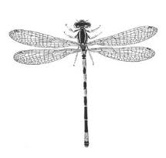 | - Two pairs of wings with several or many cross veins  - Large compound eyes present on the head  - Three pairs of legs with exoskeleton  e.g. Dragonflies, Damselflies

B. Orthoptera
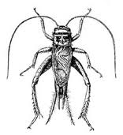 | - Two pairs of wings, fore wings are thin, hind wings are large with cross veins  - Hind legs are thick and long, used for jumping  e.g. Grass hoppers, Crickets

C. Phasmida
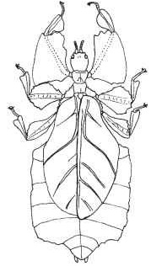 | - Body flat leaf like or long and slender, stick like  - Wingless  e.g. The Walking Sticks,

D. Dictyoptera
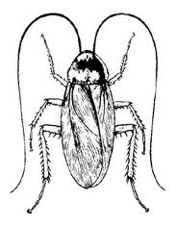 | - Body flattened, swift on foot  - Upper wings are bright and thin  - Lower wings with cross veins  e.g. Cockroaches

E. Mantodea
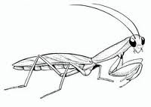 | - Two pairs of wings present  - Front legs adapted for catching insect preys  e.g. Praying Mantis

F. Isoptera
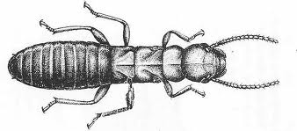 | - Soft body  - Wings are equal in size and with indistinct veins  - In some forms wings are absent.  - Winged insects normally come out during rainy season.  e.g. Termites, White Ants

G. Thysanoptera
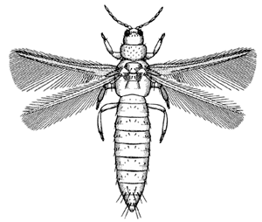 | - Small in size  - Pigmented body  - Thin wings with veins and hairs  e.g. Thrips

H. Heteroptera
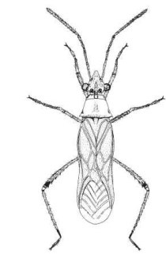 | - Large, hard body  - Fore wings thick, sometimes needle like  - Hind wings with cross veins  - Suck blood from other animal’s body  e.g. Bug

I. Homoptera
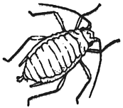 | - Generally small insect  - Soft legs, two pairs of wings with cross veins  - Anterior part of head with sucking mouthparts  - Wing less insects are also found in some stage of life cycle  e.g. Aphids, Cicada, White flies, Leaf hoppers

J. Coleoptera
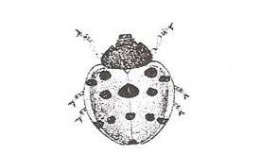 | - Two pairs of wings, fore wings hard called elytra, hind wings with cross veins  - Bright in colour  e.g. Lady bird beetle, Dung beetle

K. Hymenoptera
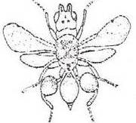 | - Two pairs of wings with cross veins  - Hind wings are always smaller than fore wings  e.g. Honey bee, Ant, Wasps

L. Diptera
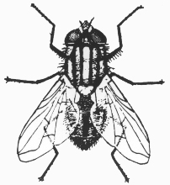 | - Generally smaller in size  - Only fore wings present with less cross veins  e.g. Flies, Mosquito

M. Lepidoptera
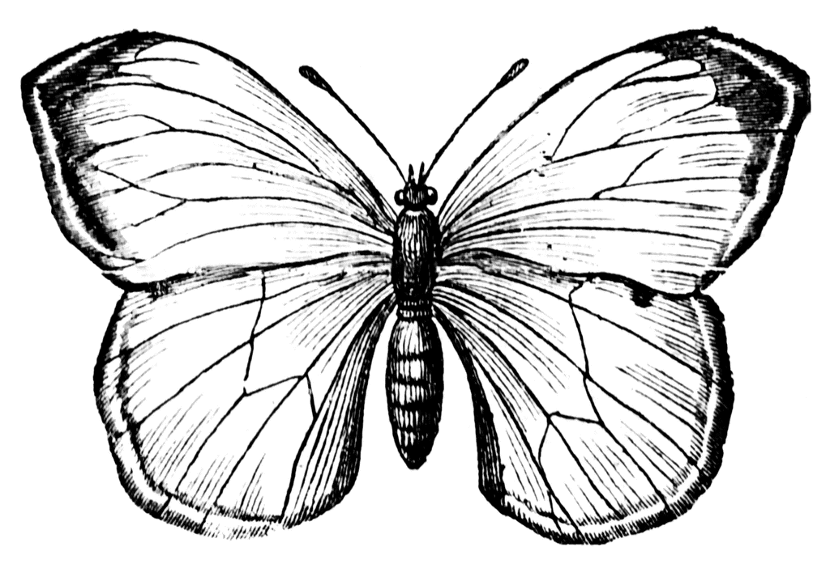 | - Two pairs of wings with fine scales  - Body and wings are thin and flat  - Wings are bright in colour  e.g. Butterflies, Moths
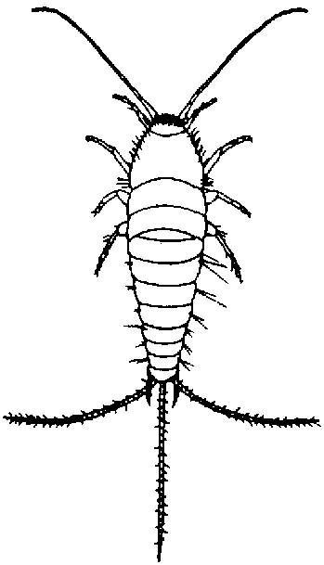
N. Thysanura
- Small, wing less, soft body
- Whole body is covered with silvery hairs

e.g. Silverfish, Bristletails

O. Collembola
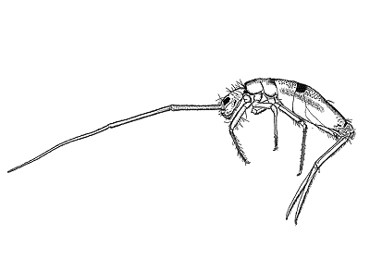 | - Small, wing less, soft body  - Spring like structure present at the end of the tail, help in jumping  e.g. Springtail

2.1.1.3 Mollusk

Mollusks are represented by snails, mussels etc. They can be found in marshy areas as well as in the high land. Observation place for mollusks may be marshy land, agricultural field during monsoon, bund area of the field etc.

2.2 Vertebrate Animals

2.2.1 Fishes

Fishes can be found from small ponds, beels and rivers in the village. Fishes can be distinguished based on the structure, scales, colour, size etc. A total of 2586 species of fishes have been recorded from India.

To observe fish diversity of the particular place:

- Collect the names of fishes cultured in the village wetlands
- Collect the names of non-cultured fishes
- Also collect the information regarding the fishes which are not found nowadays from elderly people

2.2.2 Amphibia

The group amphibian is represented by frogs, toads and newts. They are the cold blooded animals. Night time is the best time to observe Amphibia. In India about 209 species of amphibians have been recorded. Frogs and toads eat harmful insects of paddy field and therefore beneficial for the human being.

To observe and collect Amphibia specimen

- Pit fall trap can be used near the water bodies or paddy field. The trapped specimen can be collected and observed later on. Amphibia can also be collected by cloth nets and by hand.
- Species can be identified by the call of the Amphibia

2.2.3 Reptiles

Reptiles include snakes, lizards, crocodiles, turtles etc. Snakes may be poisonous or non- poisonous. A total of 485 species of reptiles are found in our country. These animals can be found during day time as well as night time.

Reptiles may be observed

- at the selected sites by direct sighting (on trees, on ground, under stone, in crevices, near water)
- by the molt of the snakes
- from the elderly people about the common reptiles found in the area

2.2.4 Birds

Birds are colorful feathered animals. The male and female birds can be easily distinguished as the males are more colorful than females. Early morning and dusk time are the best for observing birds. The call, colour, structure of wing, beak, legs etc. are important for observing a bird species.

Birds can be observed at the places where insects, amphibia, reptiles etc are observed.

- Select 50 m., long site. Imagine a circle of 10 m., radius at the two end points of the 50 m., long site.
- Stand at the centre of the circle and observe the birds for 10-15 minutes.
- Note the name of the known birds. Record major features of the unknown birds.

2.2.5 Mammals

Mammals are placed at the highest level of animal kingdom. They are characterized as warm- blooded animals with hairy body and by the presence of mammary glands. In India, a total of 372 species of mammals are found. The smell, call, foot-print, excreta etc., are important for observing mammalian species. Generally most of the mammalian species come out during night. Therefore for direct observation, night time is preferred. Indirect information may be collected from their foot-print, call, habitat etc.

2.2.6 Domesticated Animals

Domesticated animals include cow, buffalo, sheep, goat, poultry chicken, duck etc.

Figure: Different types of Legs of Birds

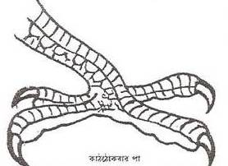 | 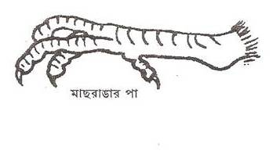 | 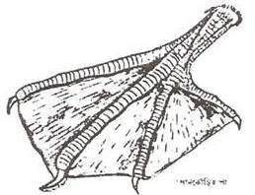
Woodpecker | Kingfisher | Cormorant
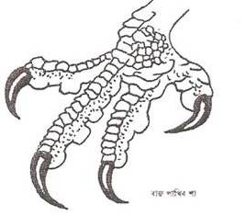 | 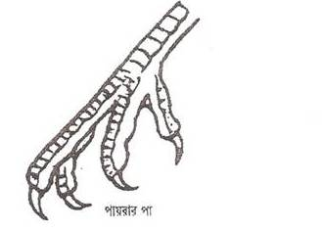 | 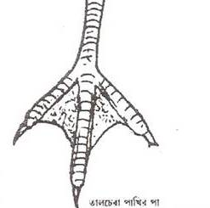
Eagle | Pigeon | Palm Swift

Figure: Different types of Beaks of Birds

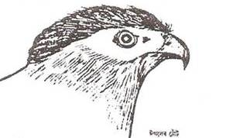 | 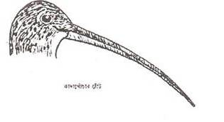 | 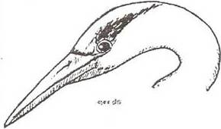
Eagle | Fantail Snipe | Egret
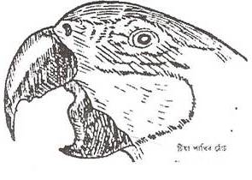 | 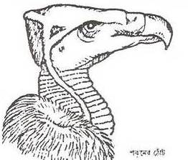 | 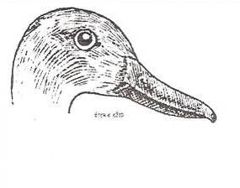
Parakeet | Vulture | Duck

3.0 Plant Diversity (Flora)

Plant kingdom can be divided into Gymnosperms and Angiosperms.

3.1 Cryptogams

Cryptogams are non-flowering plant group and reproduces by spores. This group can be divide into three sub-groups:

- Thalophyta: Generally once-celled or multi cellular body. In case of multi-cellular species, body parts cannot be differentiated. e.g. Algae, Fungi
- Bryophyte: Small, shoot, leaves present, generally grows on marshy land. e.g. Moss
- Pteridophyte: The plant is having distinct root, shoot and leaves. Vascular bundle present. e.g. Fern

3.2 Phanerogams

These are the flowering plants and reproduce by seed. This group is further divided into two groups:
- Gymnosperms: When the seeds are open without any external coating. e.g. Pine, Cycas
- Angiosperms: When the seeds have outer seed coating. This may again be divided into two groups called Monocot and Dicot. The first one having only one undivided seed, like rice and wheat and the second one has got divided seed, like gram, mango etc.

The dicot group is again divided into following three sub-groups:

3.2.1 Herbs:

- Plants with soft shoot
- Herbs can be on the basis of duration of lifecycle.
- Life cycle completes in one year. e.g. Paddy, Wheat
- Life cycle completes in two years. e.g. Radish
- Life cycle completes in more than two years. e.g. Ginger
- Herbs can also be divided in to climbers and creepers

3.2.2 Shrubs:

- The plants larger than herbs but smaller than trees.
- Woody stem, medium height, branched. e.g. China rose,

3.2.3 Trees:

- Plants with long, woody stem.
- Branching out after a certain height from the ground. e.g. Mango, Banyan

Observation Procedure for Plants

- Wild Plants:
- Demarcate 50 m., long area
- Demarcate five 10 m., X 10 m., quadrant, one at the middle of 50 m., length and two each at the two sides of end two points
- Write description of the site
- Write down the uses of the plants especially medicinal use, abundance, and plants, which were present and used in the earlier times but no longer available. this data can be collected from the help of local villagers specially the elderly people.

- Agricultural Crop Plants

Agricultural crops include cereals, pulses, vegetable, spices, oil seeds, fiber yielding plants, sugar yielding plants, cultivated fruit and flowers, green manure etc.
[S=Summer; M=Monsoon; PM=Post Monsoon; W=Winter]

Paddy:

Paddy can be of many varieties, both indigenous as well as high yielding. Farmers are the best source for getting the information regarding cultivation of rice varieties. The morphological characters to be noted are:

- Total plant: seedling height, plant height
- Culm: culm number
- Leaf: leaf length and width, leaf angle, flag leaf angle and colour
- Panicle: panicle type, length, weight, secondary branching pattern, number of
- grains, proportion of sterile grains, panicle axis
- Grain: grain length and width, 100-grain weight, brown rice length and width, brown rice colour, aroma etc

Disease and pest resistance of plants may be observed directly by the rate incidence of pest insects and diseases.

- Horticultural Plants

This includes flowering and fruit-bearing plants like Mango, Guava, China Rose, Jasmine etc.

- Timber yielding Plants

This type includes woody plants grown for timber. E.g. Teak, Mahogany etc.

Preparation of herbarium sheets for identification of plant species

Herbarium sheets are important tools for identification of plants species. Specimen can be kept for many years as herbarium sheet for future research. Herbarium sheets must be prepared in case the plants cannot be identified at the site.

Following materials are needed for herbarium sheet preparation:

- Bag (jute, paper, polythene) for keeping the specimen collected
- Knife for cutting the plant specimen
- Note book and pencil for note down the information required
- Weight for pressing the plant specimen between newspapers

Procedure:

- Collect the plant specimen with leaves, flower and fruit. The size of the specimen must be 30 cm. x 20cm. Put necessary label with number, location, date of collection and name of the collector.
- Now write down these information in the notebook for future reference
- Put the specimen in between two newspapers and place the leaves, flowers and fruit properly
- Put the specimen within the paper on a plain surface and place some weight on it
- Change the newspaper as and when required for complete drying the specimen.
- Place the dried specimen outdoor for sun-drying
- Take a hard art paper of size 41.7 cm. X 26.5 cm. Place the dried specimen at the center of the paper and glued or stitched it with the paper.
- Put herbarium label at the lower right hand side of the herbarium sheet with information like scientific name, family, location/place, date, collects name, altitude from msl etc.

This complete herbarium sheet can be preserved for many years with proper care.

3.3 Medicinal Plants Survey

In case the area in rich in medicinal plants, special focus is to be given to document the resources and its current use pattern. Based on the results of the documentation the BMC will be in a position to determine the resource potential, prospects of cultivation, sustainable use and trading.

3.4 Ritualistic and Social Use of Biodiversity

The population in the study area may use different biological resources for religious and other ritualistic purposes. In the rural areas, such materials are normally collected from nature but in the urban areas such materials are traded through commercial stores.

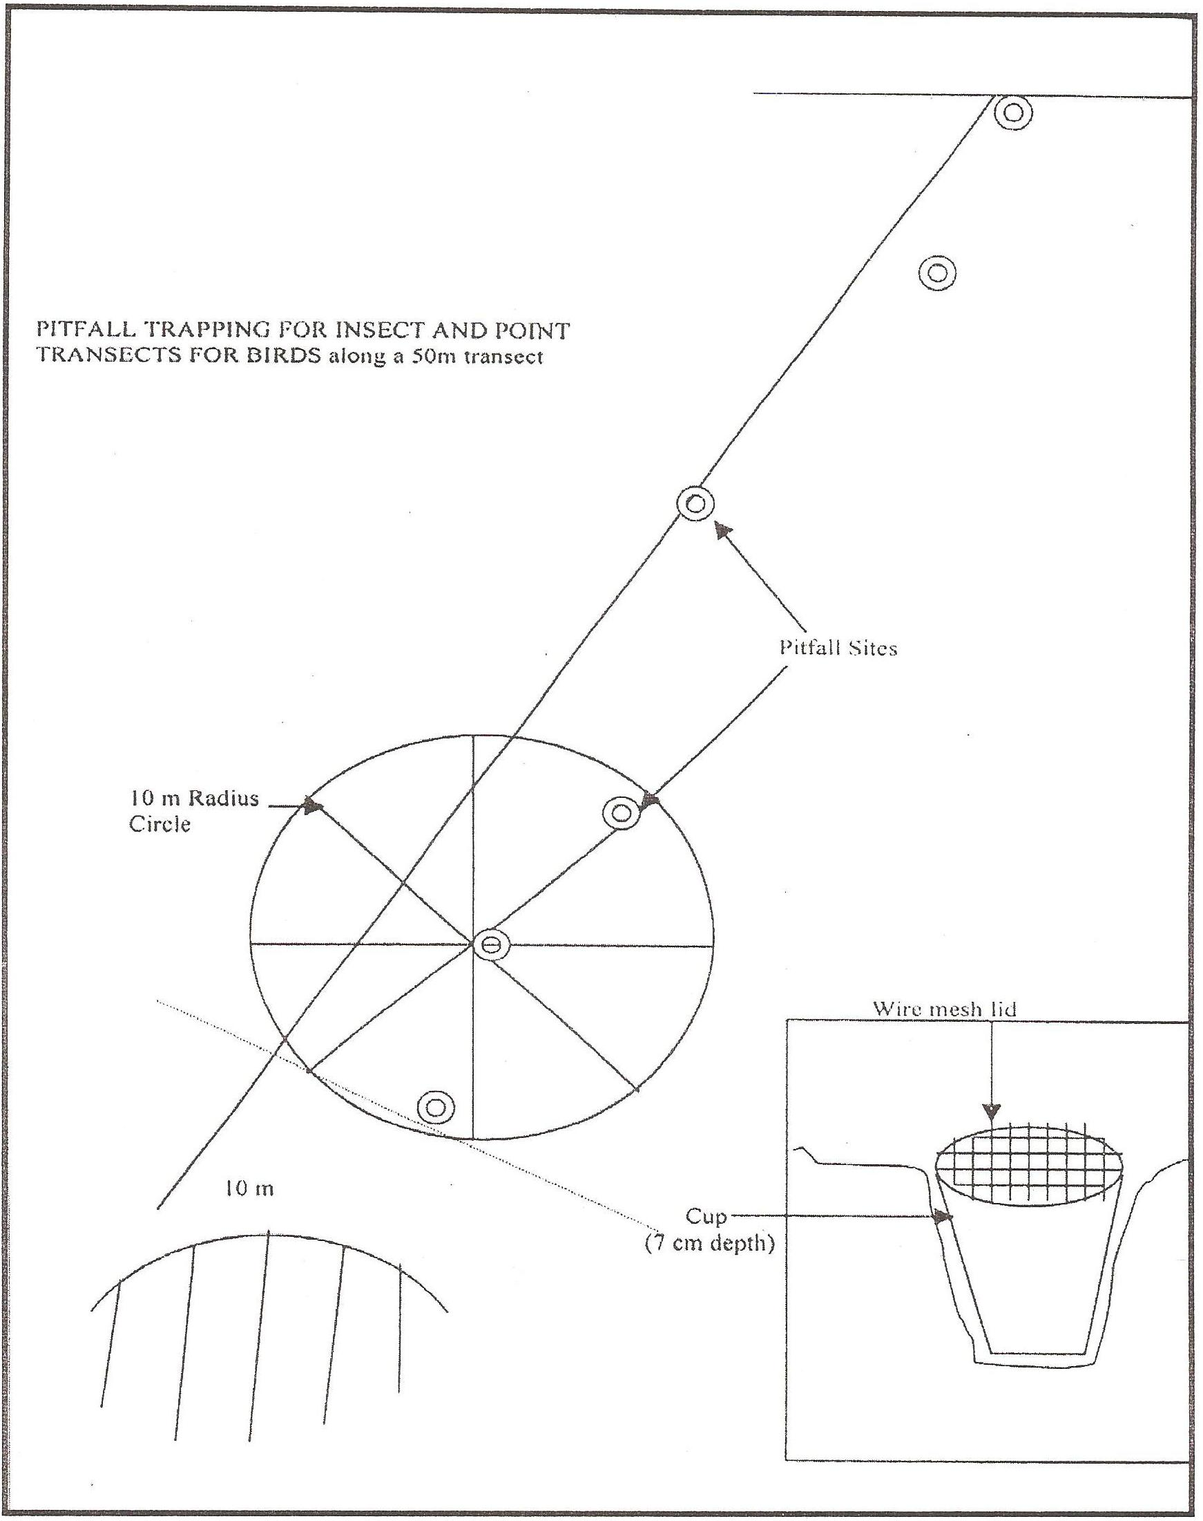

End of Part III

